Homework 5
Note: 這次Lab是作loop 的練習, 請不要使用pow函數, 請不要使用陣列.
(This homework designed for the loop practice. Please do not use array or pow function)
1. Write a program to approximate the value of e using the formula:
e = 1 +  +  +  +…
(a). Stop when the added term is less than 10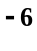.
(b). Stop when the difference between the two successive terms is less than 0.001.
2. Write a program to approximate the value of sin(x) using the formula:
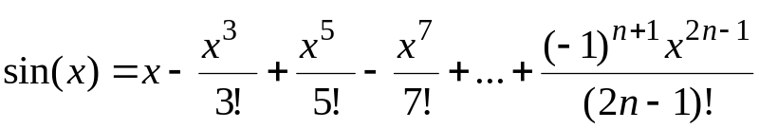
(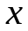值由keyboard key in ).
The program stop when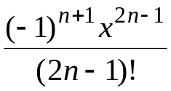 < 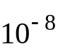
3. Write a program that prompts the user to input a positive integer and then outputs the individual digits of the number.
( while loop only )

4. Write a program to convert binary numbers to decimal.
(First you can decompose a binary number into separate digits.)

5. (加分題, 可以不寫) This is an extra point question, you may not write.
In cryptarithmetic puzzles, mathematical equations are written using letters. Each letter can be a digit from 0 to 9, but no two letters can be the same. Here is a sample problem:

SEND + MORE = MONEY (9567+ 1085 = =10652)

A solution to the puzzle is
S = 9, R = 8, O = 0, M = 1, Y = 2, E = 5, N = 6, D = 7

Question:

Write a program that finds solutions to the cryptarithmetic puzzle of:

TOO + TOO + TOO + TOO = GOOD

The simplest technique is to use a nested loop for each unique letter (in this
case T, O, G, D). The loops would systematically assign the digits from 0-9
to each letter.

For example,
it might first try T = 0, O = 0, G = 0, D = 0, then
T = 0, O = 0, G =0, D = 1, then
T = 0, O = 0, G = 0, D = 2, etc. up to
T = 9, O = 9, G = 9, D = 9.

In the loop body test that each variable is unique and that the equation
is satisfied.

Output the values for the letters that satisfy the equation.

